**BCVD1006 – Full Stack Development – Lab 3**

* HTML5 Syntax

Developer Note:

* Please create a separate file for each exercise ie. exercise1.html
* Validate your HTMLmarkup here if needed during development  
  <https://validator.w3.org/#validate_by_input>
* Use the following HTML starter code

<!DOCTYPE html>

<html>

<head>

<meta charset="utf-8">

<title>Article</title>

</head>

<body>

</body>

</html>

**Exercise 1:**

Create an HTML document which uses **article** element.*(hint* ***<h1>*** *and* ***<p>*** *may be used)*

***Displays in Browser:***

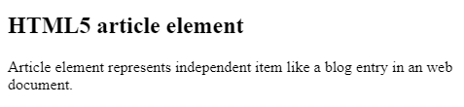

**Exercise 2:**

Embed **audio** in a HTML document with control and play audio repeatedly.  
<https://developer.mozilla.org/en-US/docs/Web/HTML/Element/audio>

***Displays in Browser:***  
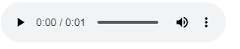

**Exercise 3:**

Create a **hyperlink** to the following we address. https://www.w3resource.com

The link will have a **media attribute**.

***Displays in Browser:***



***Clicking on link will have following behavior***  
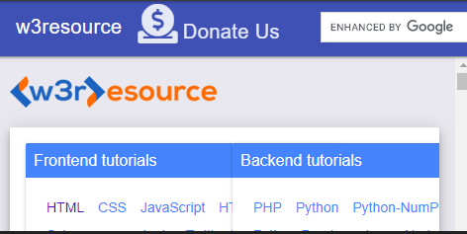

**Exercise 4:**

1. Create an unordered list of items needed (Pizza party is an example here)
2. Create two nested list of items
3. Use a fieldset and header elements for the header

***Displays in Browser:***

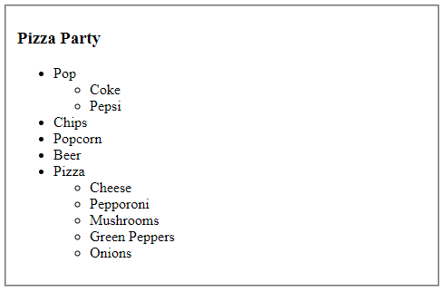

**Exercise 5:**

1. Create an HTML Form using the <form> tag
2. Use a fieldset to wrap the form element. (The width does not matter, the fieldset box can be the entire 100% of window by default)
3. Create two clickable button such that the Google will submit and redirect the form to <http://www.google.ca> and Cancel with do nothing. (no redirection)
4. Hint: you will have to use form and button attributes here.

***Displays in Browser:***

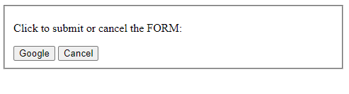

***Clicking on the Google button will redirect the browser to the following page:***

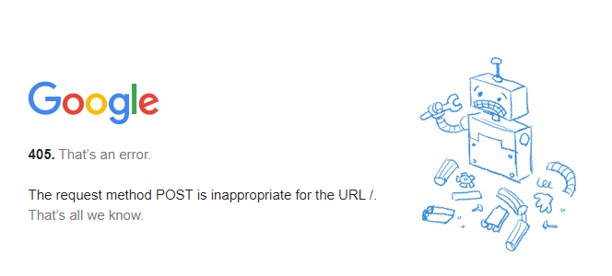

**Exercise 6:**

1. Create a complex form with input elements.
2. Use input attributes to add the placeholder text
3. Add a select element for the drop down list of items
4. Add a button element to submit the form  
     
   ***Displays in Browser:***  
   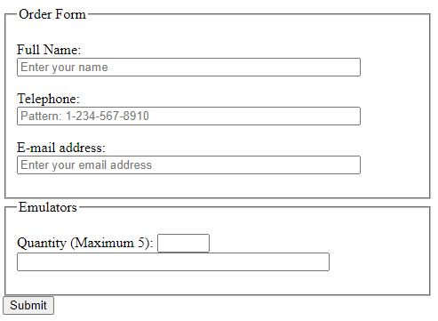

***Clicking on the drop down should reveal a list of items.***

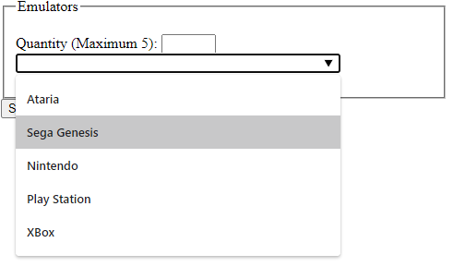

**Challenge:**

Using HTML attributes (min, max, required, format) use the build in validator to trigger validation on required values and formats on Form Submission (Button Click)

